ASSIGNMENT-5.1
NAME: G.Laxmi Pranav
H.T.NO:2303A52403
BATCH:36
Task Description #1 (Privacy in API Usage)
Task: Use an AI tool to generate a Python program that connects to a weather API.
Prompt:
"Generate code to fetch weather data securely without exposing API keys in the code."
Expected Output:
- Original AI code (check if keys are hardcoded).
- Secure version using environment variables.
CODE:
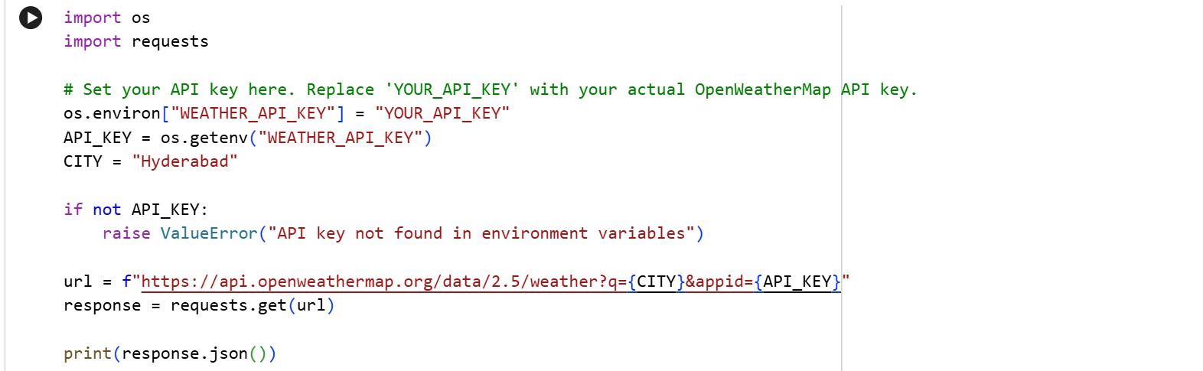
OUTPUT:
Task Description #2 (Privacy & Security in File Handling) Task: Use an AI tool to generate a Python script that stores user data (name, email, password) in a file.
Analyze: Check if the AI stores sensitive data in plain text or without encryption.
Expected Output:
- Identified privacy risks.
- Revised version with encrypted password storage (e.g., hashing).
CODE:
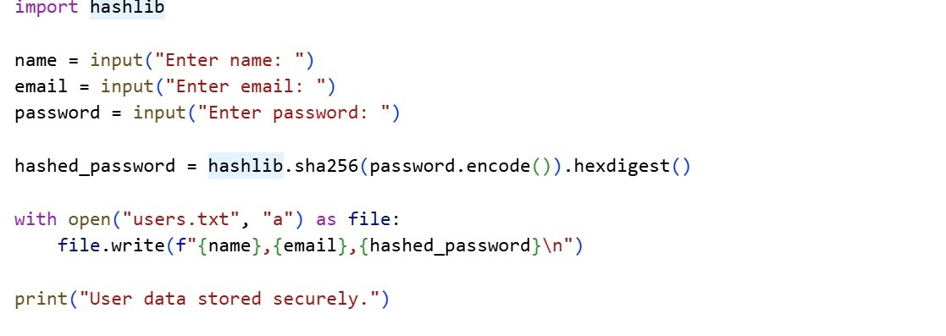
OUTPUT:
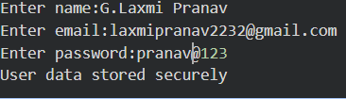
Task Description #3 (Transparency in Algorithm Design)
Objective: Use AI to generate an Armstrong number checking function with comments and explanations.
Instructions:
- Ask AI to explain the code line-by-line.
- Compare the explanation with code functionality.
Expected Output:
- Transparent, commented code.
- Correct, easy-to-understand explanation.
CODE:
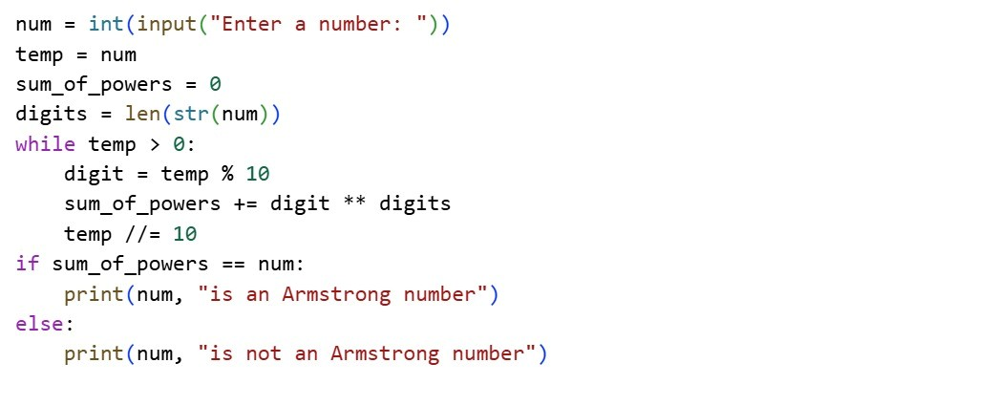
OUTPUT:
Task Description #4 (Transparency in Algorithm Comparison) Task: Use AI to implement two sorting algorithms (e.g., QuickSort and BubbleSort).
Prompt:
"Generate Python code for QuickSort and BubbleSort, and include comments explaining step-by-step how each works and where they differ." Expected Output:
- Code for both algorithms.
- Transparent, comparative explanation of their logic and efficiency.
CODE:
QUICK SORT:
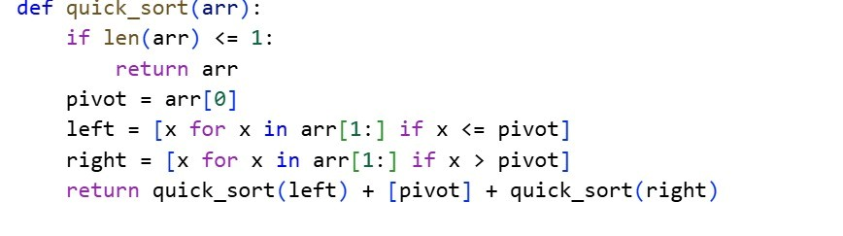
BUBBLE SORT:
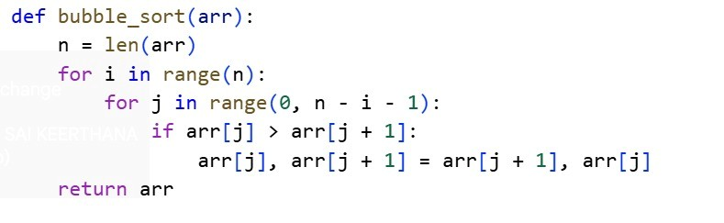
COMPARISON TABLE:
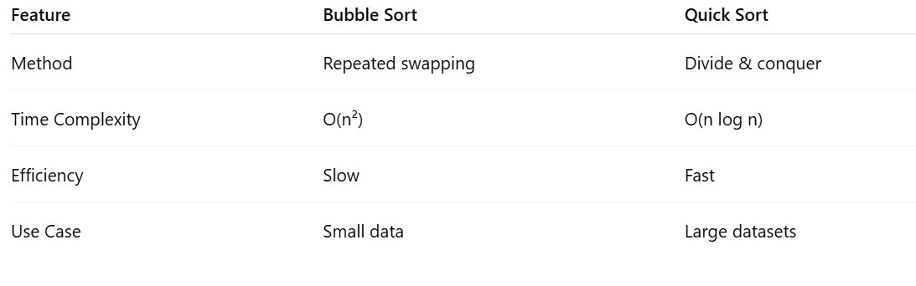
Task Description #5 (Transparency in AI Recommendations) Task: Use AI to create a product recommendation system.
Prompt:
"Generate a recommendation system that also provides reasons for each suggestion."
Expected Output:
- Code with explainable recommendations.
- Evaluation of whether explanations are understandable.
CODE:
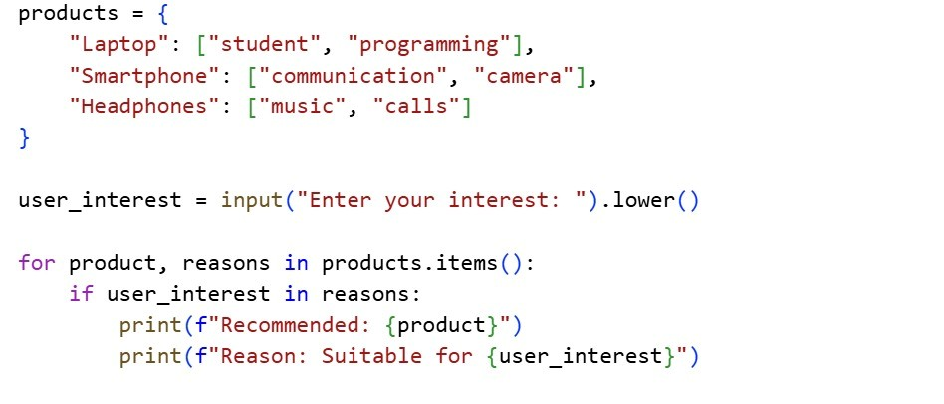
OUTPUT:


